
The
Webb Institute
at Ruskin
For many years, labour movement activists from Eastern Europe have been visiting Ruskin College, sponsored by the Webb Memorial Trust. The result is an influential network of people dedicated to economic and social justice across the region.
Based at Ruskin College in Oxford, the Webb Institute for Leadership in Democracy works to strengthen and extend this community through an innovative programme of training and other activities.
"The Webb Memorial Trust is delighted to support this new Institute, which will enhance the skills of emerging leaders and help strengthen the new democracies."
Mike Parker, Honorary Secretary, Webb Memorial Trust

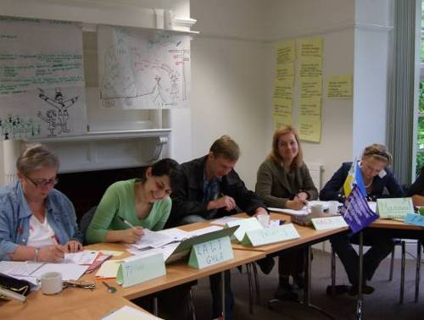
- Leadership Development
Potential leaders from trade unions and NGOs in Eastern Europe (outside the EU) meet to explore ideas about leadership, practical skills and personal development.
- An online network
Programme participants then connect via the internet with former Webb scholars to share best practice and identify areas of common interest.
- In-country seminars and events
The Webb Institute creates opportunities for practitioners and educators to debate ways in which trade unions and NGOs can work together to build civil society.
Next events (main programme)
Dates 15-25 March 2009 (application deadline: 14 December 2008)
Eligibility Nationals of Albania and Balkan states (outside the EU)
Language(s) This course will be run in English*

Dates 22 June - 3 July 2009 (application deadline: 27 March 2009)
Eligibility Nationals of CIS states (outside the EU)
Language(s) This course will be run in English and Russian
*There is an option to bring interpreters by arrangement

Leadership in democracy
The Webb Institute Leadership Development Programme is available to trade union and NGO activists from countries in Eastern Europe outside the European Union.
“The group was very diverse, but united by
the same interest in changing the ways their organisations worked”
This accredited course focuses on the practical development of skills, with discussion and analysis of participants' own experiences as well as case studies and the theory of democratic leadership.
“I discovered how to apply my knowledge.”
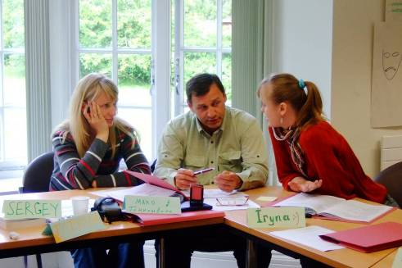
Key themes
Leading in organisations
- What does a democratic, non-discriminatory organisation look like?

- How does leadership relate to its structure, resources and culture?
- What can we learn from different models of leadership, from ideas about women and leadership, and from regional case studies?
“Together we ended up coming up with a lot of good ideas”
Issues-based campaigning

- How can strategic planning help
us to prioritise, plan and deliver
a programme of change, analyse
risks involved, and allocate resources?
- How can we use campaigning and
organising to build support for key
issues and to build a strong
organisational base?
“Environmental justice was a new topic for me.
Before, I had never considered this as part of trade union work”
Network building
- How can we work together to develop civil society?
“Working in small groups
solving practical and theoretical problems was useful and dynamic”
- What are the best methods to develop and support activists e.g. mentoring schemes to build networks of support internally and across civil society?
“It was very interesting to work
with NGO representatives since, in my country, contact is rare”
- Participants will be able to explore particular interests that they and their organisation have identified through one to one and small group study and support.
“We learned to plan our work,
identify problems and find solutions to resolve them.”

Project work
As part of the programme, participants will undertake a project in their own country which applies the skills they have learned, and which relates to one of the following: mentoring, networking, campaigning, trade union organising and write an account of it for the second module.
Mentoring and personal development
To help with project work and support further professional development, participants are asked to identify someone in their organisation who will act as a mentor.
A mentor will be willing and able to meet with on a regular basis for informal discussion about the individual’s development in the organisation.
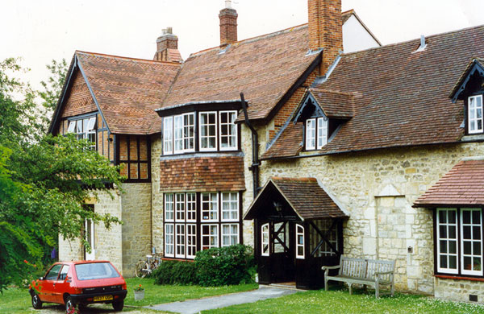
The Webb Institute
at Stoke House
The Webb Institute is based at Stoke House on the outskirts of Oxford. Stoke House offers state-of-the-art teaching facilities, with full board accommodation in en-suite bedrooms.
“The place is great, it’s beautiful, calm. You never get distracted.”

For more information
To find out more about the Institute and its programmes, please contact
Webb Institute Co-ordinator: Joanna Cain (jcain@ruskin.ac.uk) or
Webb Institute Development Officer: Jenny Barrett (jbarrett@ruskin.ac.uk)
Webb Institute for Leadership in Democracy
Ruskin College, Stoke House, 7 Stoke Place, Oxford OX3 9BX, UK
tel: +44 (0) 1865 759654; fax: +44 (0) 1865 741043
website: www.webbatruskin.org

www.webbmemorialtrust.org.uk
see www.aset.ac.uk

